GUÍA EVALUADA DE UNIDAD 1 “Food & Health”
Guía n° 2 English Language

Nombre: |  | Curso: | 6th | Fecha

INSTRUCCIONES:
- Cuenta con 3 días para responder la guía.
- No se podrá entregar la guía sin estar resuelta completamente.
- La guía puede ser resuelta con apoyo de un diccionario y sus cuadernos de ser necesario. No está permitido copiar trabajos de otros compañeros/as.
- Utilizar lápiz pasta azul o negro.
- Es IMPORTANTE ver los videos adjuntos en links para aclarar dudas.
- La guía debe ser entregada el día viernes 27 del presente mes.

Objetivos: Reconocer e identificar el presente simple y el presente continuo.
Contenidos: Presente continuo y simple en su forma afirmativa, negativa e interrogativa.

ITEM I.- Explanation about what is presente continuous amd how to use it, reinforce what is present simple and how to use it.

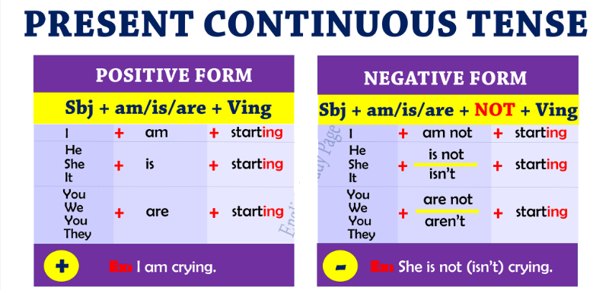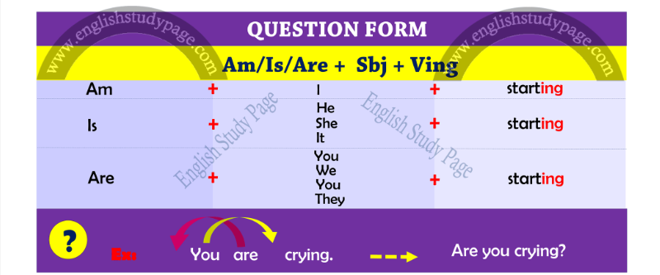

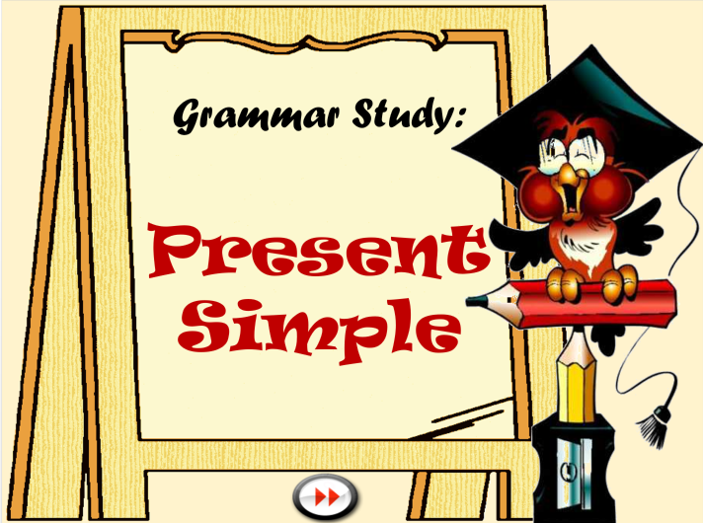 | 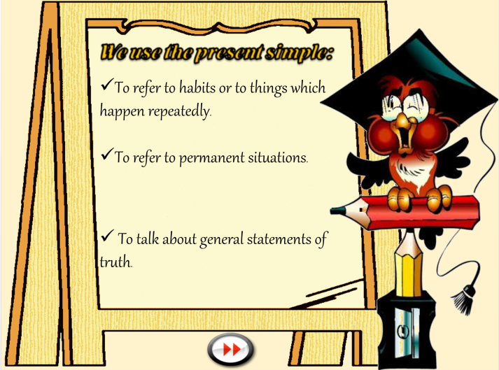
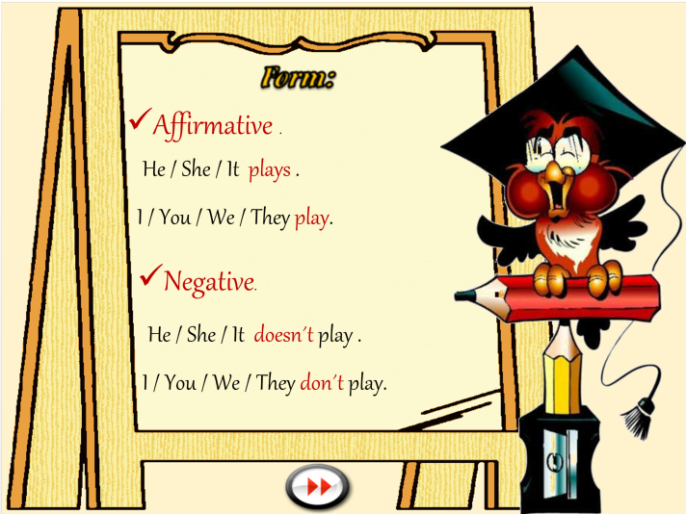 | 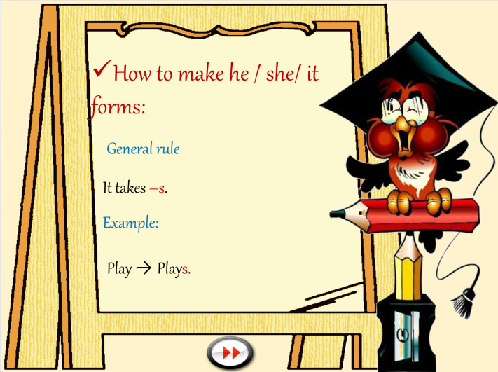
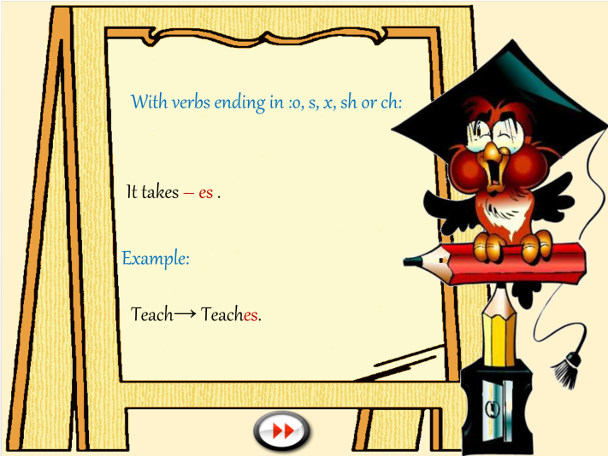 | 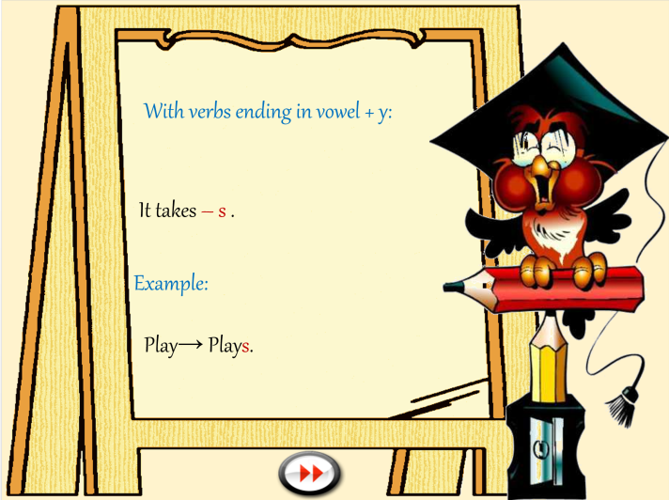

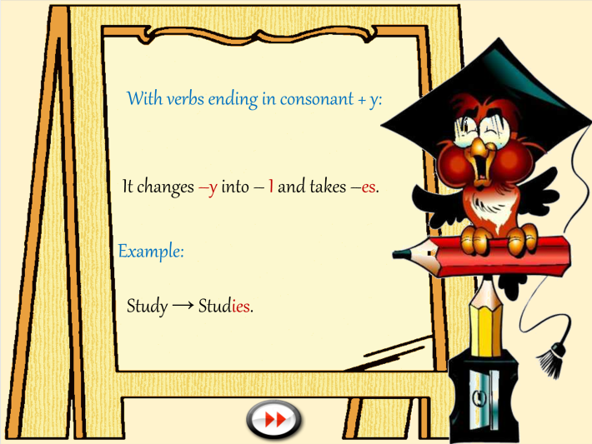

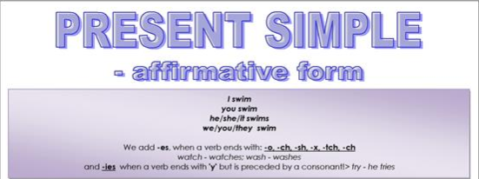

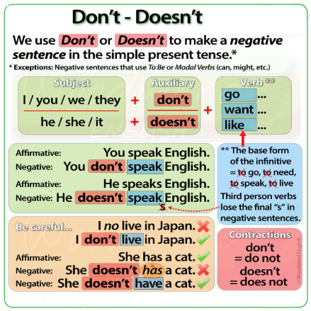 | 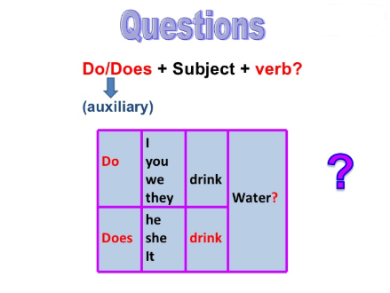

ITEM II.-

Examples about what does he/she wear?

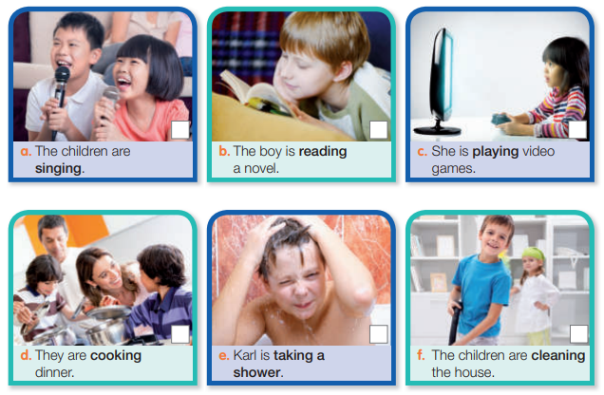
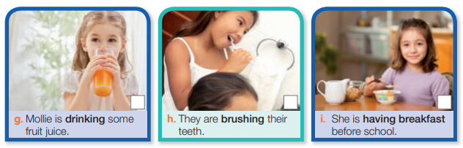

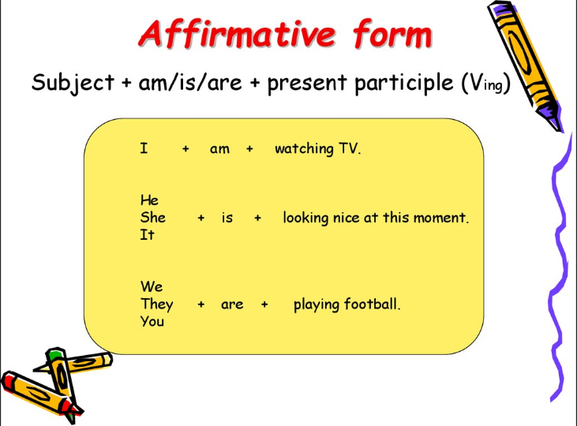
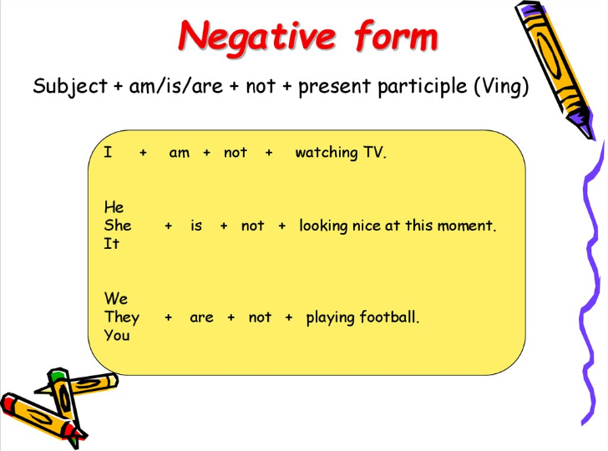
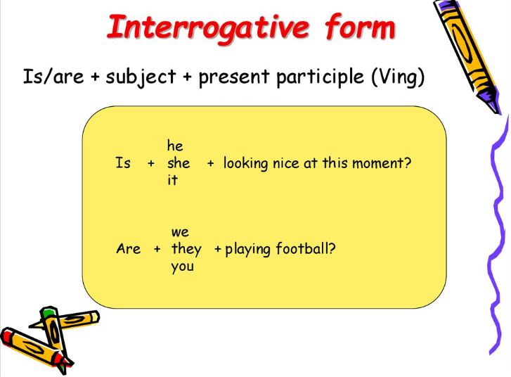

For more examples, please watch the next videos here: (about present continuous)

https://www.youtube.com/watch?v=hfgni8tQl3o
https://www.youtube.com/watch?v=NahbNTKtAj8

EXAMPLES ABOUT PRESENT SIMPLE (STRUCTURE):

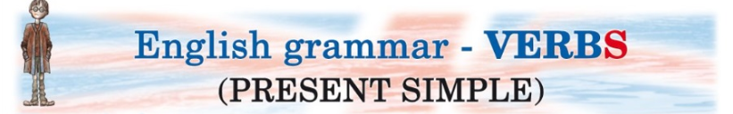

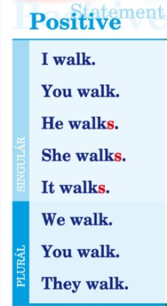 | 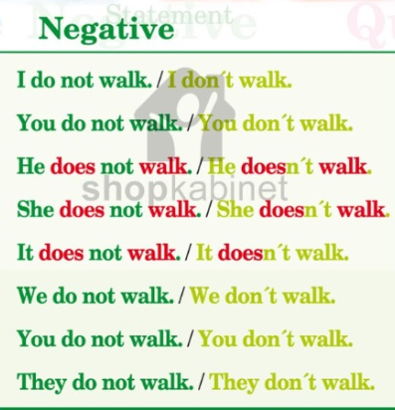 | 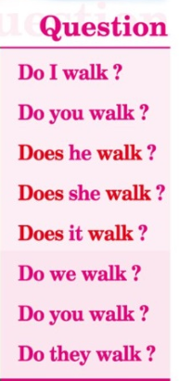

For more examples, please watch the next videos here: (about presente simple)

https://www.youtube.com/watch?v=RB822HdHqko (part 1)
https://www.youtube.com/watch?v=YBuXqHOt2Kk (part 2)
https://www.youtube.com/watch?v=xWXRMNDR01Q (adding final ‘s’ t the verbs)
https://www.youtube.com/watch?v=sTaEsrBY21E (negative sentences part 1)
https://www.youtube.com/watch?v=hcqJfVhdA5Y (negative sentences part 2)
https://www.youtube.com/watch?v=oAjXEYqO5nQ (interrogative form)

EXAMPLE ABOUT WHAT IS THE DIFFERENCE BETWEEN PRESENT CONTINUOUS AND P. SIMPLE:

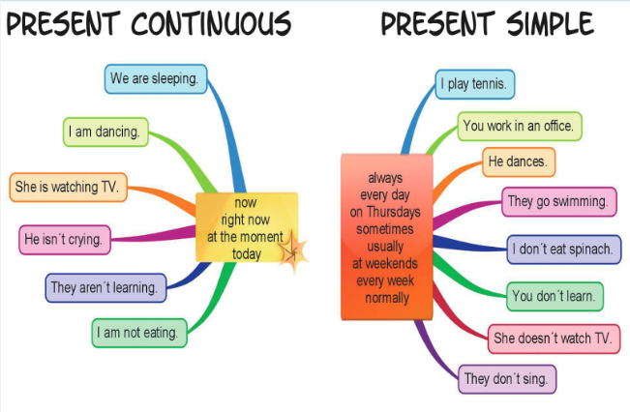

For more examples, please watch the next video here:
https://www.youtube.com/watch?v=NahbNTKtAj8

ITEM III.-
EXERCISES WITH PRESENT CONTINUOUS:

In exercise A, you need to write “is” or “are” in the blanks, example: Dina _is_ playing tennis.
In exercise B, you must put final ‘ing’ to the verbs given in brackets, ex: Dina is _playing_ tennis(play)
In exercise C, you must write “is” or “are” and sometimes add the ‘ing’ to the verb in brackets, example:
Dina _is_ _playing_ tennis (play) 🡨 notice we need to write ‘is’ and the verb ‘play’ with final ‘ing’
In exercise D, you must write ‘am’,‘is’ or ‘are’ at the beginning of each sentence and then write the verb with final ‘ing’ given in brackets. Example: ___ Diana _______ tennis? (play)🡪_is_ Diana _playing_ tennis?

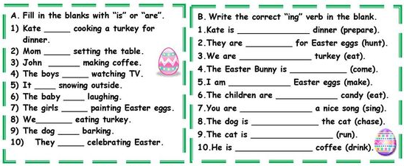

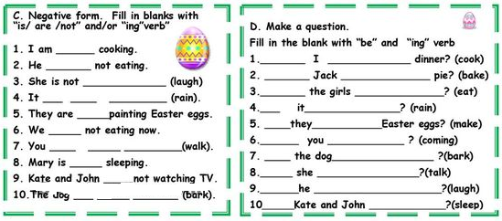

In exercise 1, you need to write ‘am, is or are’, ‘am not, isn’t, aren’t’ and the verb in brackets with final ‘ing’, examples:
He _____(play)🡪He _is_ _playing_ , My dad __________apple(eat/not)🡪My dad _isn’t_ _eating_ apple , why ___________(you/drink) water? 🡪 why _are_ you _drinking_ water?
In exercise 2, you need to write the verbs given in the blanks with final ‘ing’, example: go 🡪 going
In exercise 3, you need to re-write the sentece given into negative and question form, example:
Mary is cooking chicken and rice. 🡪 negative form: Mary is not cooking chicken and rice
- Question form: is Mary cooking chicken and rice?

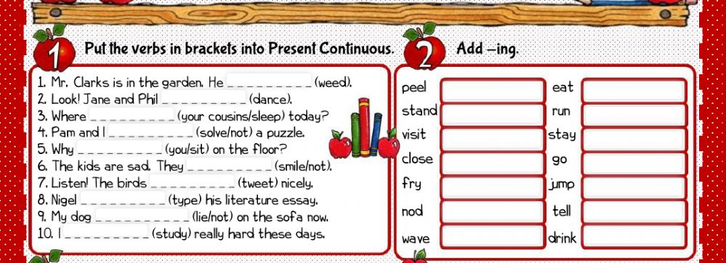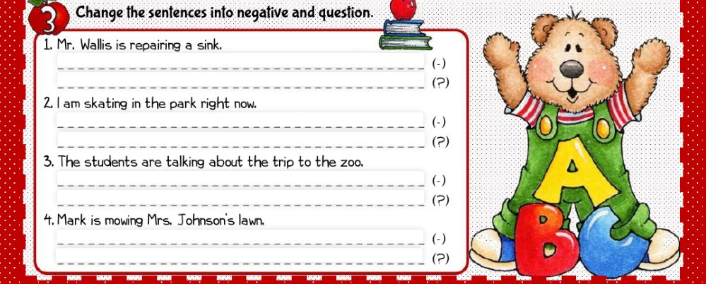

EXERCISES WITH PRESENT SIMPLE:

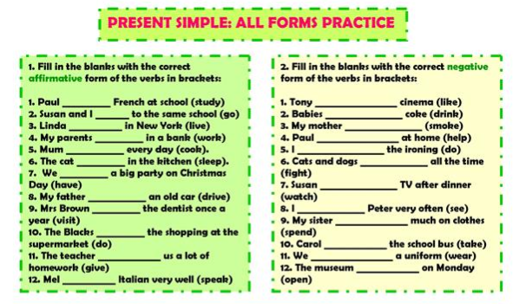
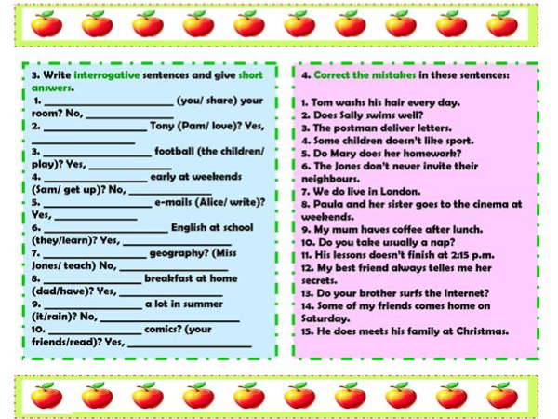

EXCERCISES IN NEGATIVE FORM: Put don’t or doesn’t plus de verb in brackets for each sentence.

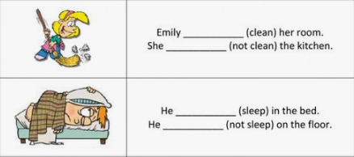

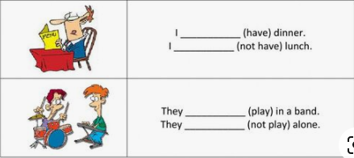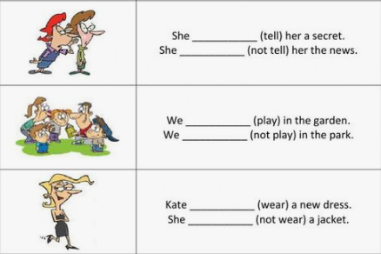

EXCERCISES WITH INTERROGATIVE FORM:

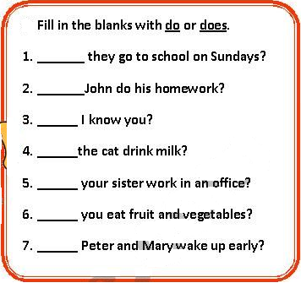

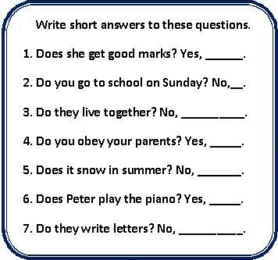

Excercises with final ‘s’ with HE-SHE-IT: Complete the table with the correct form of verbs for singular person.

Example: | Verb infinitive | 🡪 | Verb for 3rdsingular person
 | run | 🡪 | runS

Verb infinitive | 🡪 | Verb for 3rd singular person
Go | 🡪
Fly | 🡪
Wash | 🡪
Fix | 🡪
Play | 🡪
Come | 🡪
Eat | 🡪
Drink | 🡪
Cry | 🡪

